|  |
| --- |
| City of Glasgow College |
| User Manual |
| OOP: Centralia College Project |
|  |
| **Niall Ferguson** |
| **4/19/2013** |

|  |
| --- |
|  |

Contents

1. Main Menu (error reading file) 2

2. Main Menu 3

3. Adding New Student 4

4. Adding Student with ID that already exists 5

5. Deleting Student with ID that does not exists 6

6. Deleting Student 7

7. Printed report of all Students 8

8. Report of all Higher National Students 9

9. Report of all Adult Students 10

10. Quit 10

## Main Menu (error reading file)

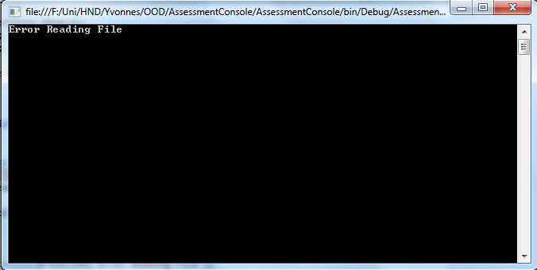

If unable to read students.txt file. Error Message is displayed to user.

## Main Menu(invalid option chosen)

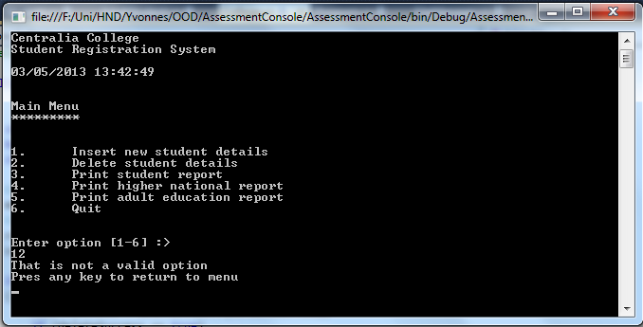

If invalid option is chosen by the user, they are prompted that it is not a valid option and returned to the main menu

## Main Menu

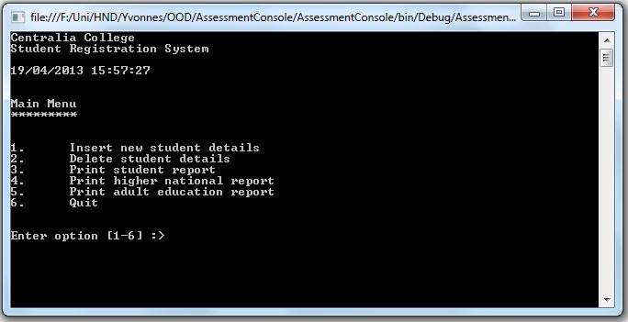

The main menu is displayed in console when the project is loaded. The main menu allows the user to input options 1-6 depending on the function required.

## Adding New Student

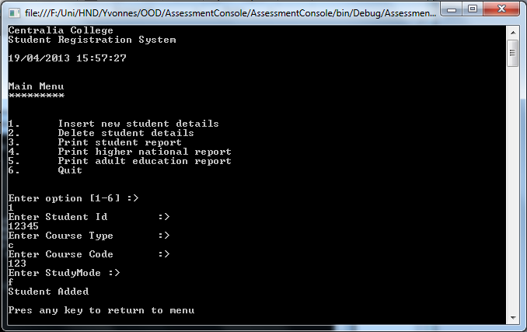

If Main menu option 1 is selected the user is taken to the Insert new student details option. The user is prompted to enter the students ID and press return. They are then prompted to enter the course type and press return. They are then prompted to enter the course code. If the course code is < 100 they are then prompted to press any key to return to the main menu, else they are prompted to enter the studymode.and press return. They are then prompted to press any key to return to the main menu.

## Adding Student with ID that already exists

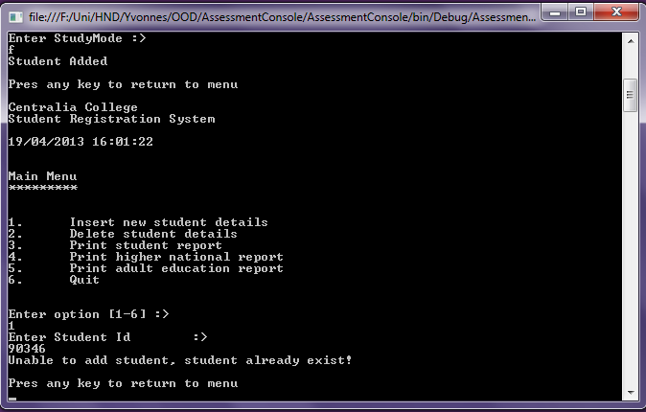

If the user tries to enter a student ID which already exists in the College a display message will inform them that “Unable to add student, student already exists!”. The user is then prompted to press any key to return to menu.

## Deleting Student with ID that does not exists

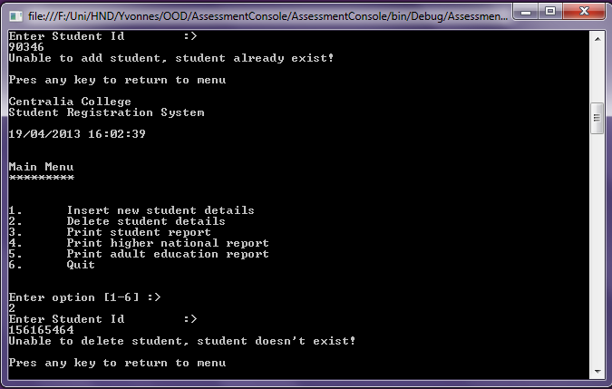

If user selects option 2 from the main menu they are taken to the delete students details menu. They are then prompted to enter the student ID of the student record they wish to delete. If the student ID does not exist in the college a display message “Unable to delete student, student doesn’t exist!”. The user will then be prompted to press any key to return the main menu.

## Deleting Student

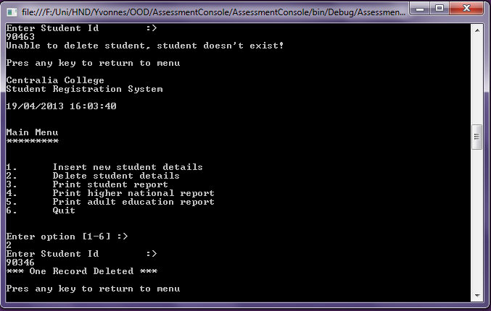

If the user enters a student ID the does exist in the college. A display message “*** One Record Deleted ***” and the user will be promted to press any key to return to menu.

## Printed report of all Students

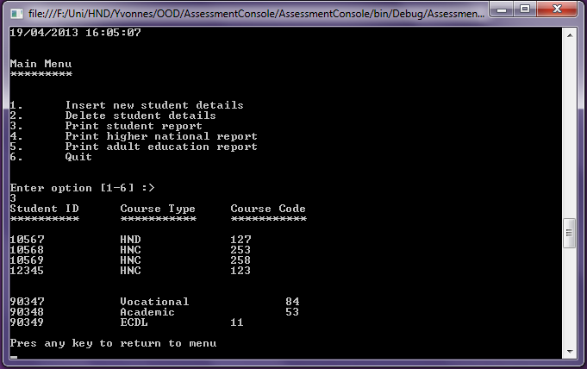

If user selects option 3 from the main menu they will be taken to the print all students menu. An output of all the user’s Student ID/Course Type/Course Code in the college dictionary will displayed on the screen. The user will be prompted to press any key to return to the menu.

## Report of all Higher National Students

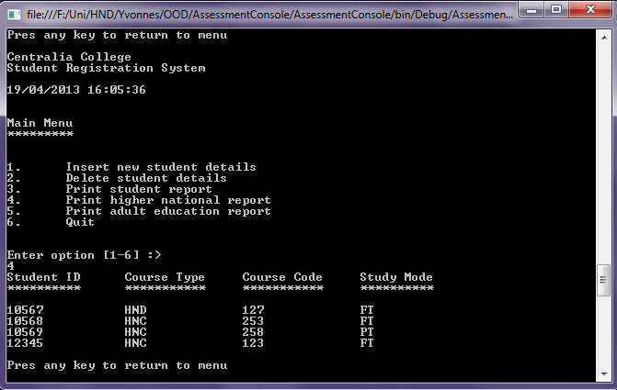

If user selects option 4 from the main menu they will be taken to the print higher national report menu. An output of all the higher national student’s Student ID/Course Type/Course Code/Study Mode in the college dictionary will displayed on the screen. The user will be prompted to press any key to return to the menu.

## Report of all Adult Students

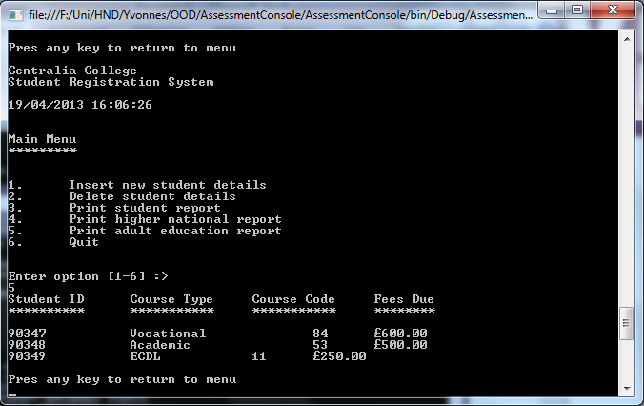

If user selects option 5 from the main menu they will be taken to the print adult education report menu. An output of all the adult student’s Student ID/Course Type/Course Code/Fee Due in the college dictionary will displayed on the screen. The user will be prompted to press any key to return to the menu.

## Quit

If user selects option number 9 from the main menu the application will quit and the user will be returned to the operating system. All changes to student records made will be saved to CSV format file called students.txt, in the programme main directory.